CEBU INSTITUTE OF TECHNOLOGY
UNIVERSITY

COLLEGE OF COMPUTER STUDIES

Software Requirements Specifications
for
Readright

Change History

Table of Contents

1. Introduction 4
1.1. Purpose 4
1.2. Scope 4
1.3. Definitions, Acronyms and Abbreviations 5
1.4. References 6
2. Overall Description 7
2.1. Product perspective 7
2.2. User characteristics 8
2.4. Constraints 8
2.5. Assumptions and dependencies 9
3. Specific Requirements 11
3.1. External interface requirements 11
3.1.1. Hardware interfaces 11
3.1.2. Software interfaces 12
3.1.3. Communications interfaces 14
3.2. Functional requirements 15
Module 1 16
Module 2 32
Module 3 45
Module 4 52
3.4 Non-functional requirements 62
Performance 62
Security 63
Reliability 64
Usability 66
Compatibility 67

Introduction

Purpose
This document is the Software Requirements Specification (SRS) for ReadRight, a mobile-first Progressive Web Application (PWA) that provides Filipino Grade 4 learners with self-directed, Phil-IRI-aligned oral reading assessment and progress tracking. It provides a complete and authoritative description of the system's functional requirements, non-functional requirements, external interface requirements, and behavioral constraints. The SRS serves as the primary reference for the development team during design, implementation, and testing, and as a formal deliverable for academic evaluation by the project panel.
The intended readers of this document are the ReadRight development team (Team Code: 2526-sem2-cs342-11), the course faculty and project panel at Cebu Institute of Technology – University, and any future evaluators of the system during pilot deployment at the partner school in Cebu City. Developers should treat Section 3 as the primary specification guide for coding and integration. Panel reviewers should refer to Sections 1 and 2 for scope and context, and Section 3 for traceability to the system's general objectives.

Scope
ReadRight is a mobile-first Progressive Web Application (PWA) that provides Filipino Grade 4 learners with self-directed, Phil-IRI-aligned oral reading practice and progress tracking. The system is installable directly from the browser onto the learner's device home screen without requiring distribution through an app store. It allows a learner to independently log in, receive a randomly assigned Phil-IRI Grade 4 passage, record themselves reading aloud via their device's camera and microphone, and receive an AI-generated assessment of their reading performance all without requiring a teacher to be present at any stage.
The system is organized around four general objectives:
- GO1, Input Quality Verification: The system verifies that each recording meets minimum audio, video, lighting, and noise quality thresholds before allowing submission to the AI pipeline.
- GO2, Audio-Based Miscue Classification and Scoring: The system transcribes learner audio, performs forced alignment, classifies all Phil-IRI miscue types, computes Words Per Minute (WPM) and word recognition percentage, and assigns a reading level classification (Frustration, Instructional, or Independent) for every valid submission.
- GO3, Video-Based Behavioral Analysis: The system detects all five Phil-IRI qualitative reading behaviors: finger-pointing, loss-of-place eye movements, monotone reading, word-by-word reading, and inaudible reading. It outputs a binary flag for each as part of the completed session record.
- GO4, Session Results Display and Personal Progress Dashboard: The system displays a complete Phil-IRI assessment summary to the learner after each session and presents longitudinal reading progress through a personal dashboard showing reading level trend, WPM progression, miscue breakdown, and behavioral history across all completed sessions.
ReadRight is scoped exclusively to the following boundaries:
- Grade 4 Phil-IRI oral reading fluency component only; comprehension assessment is excluded.
- A single primary user role: the individual Learner. There is no teacher dashboard, administrator panel, or multi-role access.
- Mobile-first PWA on smartphones and personal devices, installable from the browser. No native mobile application (App Store or Google Play) and no offline operation are within scope.
- Pilot deployment at one private elementary school in Cebu City during Academic Year 2026–2027, First Semester.
The system does not support reading comprehension evaluation, grade levels other than Grade 4, teacher-side scheduling or intervention delivery, learner-selected passages, DepEd documentation submission, or any offline functionality. These are explicitly out of scope for this version of ReadRight.

Definitions, Acronyms and Abbreviations
The following terms, acronyms, and abbreviations are used throughout this document and must be interpreted as defined below.
Term / Acronym | Definition
Phil-IRI | Philippine Informal Reading Inventory, DepEd's official standardized oral reading assessment instrument administered under ECARP.
ECARP | Every Child a Reader Program, the DepEd mandate under which Phil-IRI is administered in Philippine public and private schools.
DepEd | Department of Education, the Philippine government agency that sets national curriculum standards including Phil-IRI.
PWA | Progressive Web Application, a web application delivered through the browser that can be installed on a device's home screen, functions like a native app without requiring distribution through an app store, and uses standard web technologies (HTML, CSS, JavaScript).
ASR | Automatic Speech Recognition, the AI-based technology used to transcribe learner audio into text for miscue analysis.
WPM | Words Per Minute, the oral reading speed metric computed from the forced alignment output.
Miscue | Any deviation from the target passage text during oral reading. Includes mispronunciation, substitution, omission, insertion, repetition, and refusal to pronounce.
Miscue types | The seven Phil-IRI miscue categories: Correct, Mispronunciation, Substitution, Omission, Insertion, Repetition, Refusal to Pronounce.
Word recognition % | The percentage of passage words read correctly; the primary input to Phil-IRI reading level classification.
Reading level | The three Phil-IRI classifications assigned based on word recognition %: Frustration, Instructional, and Independent.
Forced alignment | Word-level matching of the ASR transcript to the target passage with timestamps, enabling per-word miscue classification.
Passage bank | The fixed set of Grade 4 Phil-IRI standard passages from which sessions are randomly assigned.
Qualitative behaviors | The five Phil-IRI behavioral indicators detected by the video analysis pipeline: finger-pointing, loss-of-place eye movements, monotone reading, word-by-word reading, and inaudible reading.
GO1–GO4 | General Objectives 1 through 4, corresponding to the four major functional modules of ReadRight.
SRS | Software Requirements Specifications: this document.
API | Application Programming Interface, the communication layer between the frontend and backend services.
REST | Representational State Transfer, the architectural style used for ReadRight's backend API.
CV | Computer Vision, the image processing technique used to detect physical reading behaviors from the video track.
Supabase | An open-source backend-as-a-service platform built on PostgreSQL. Used in ReadRight for learner authentication, managed database storage, and auto-generated REST API for session and progress data. The underlying database engine is PostgreSQL.
PostgreSQL | The relational database engine underlying Supabase. Session records, learner accounts, assessment results, and progress history are stored in PostgreSQL managed by Supabase.
getUserMedia | A browser API used to access the device's camera and microphone for recording. Required on both mobile and desktop browsers.
MediaRecorder | A browser API used to capture audio and video streams from getUserMedia into a submittable file. Required for all recording functionality.
Service Worker | A browser script that enables PWA features such as home screen installation and background sync. Does not provide offline functionality in ReadRight.

References
The following documents were used as source material for this SRS:
- Software Proposal Writing (Team Code: 2526-sem2-cs342-11) - primary source for all objectives, scope boundaries, system workflow, and technical constraints described in this document.
- Philippine Department of Education. Phil-IRI (Philippine Informal Reading Inventory) Administration and Scoring Manual. DepEd, Manila.
- Esteban, A. J., Calang, K., & Pagador, P. M. (2024). A review of practices and digital technology integration in reading instruction and suggestions for the Philippines. https://doi.org/10.11591/ijere.v13i6.29856
- Gao, L., Tejedor-Garcia, C., Strik, H., & Cucchiarini, C. (2024). Reading miscue detection in primary school through automatic speech recognition. Proceedings of Interspeech 2024. https://doi.org/10.21437/Interspeech.2024-1180
- Van der Velde, M., Harmsen, W., & Veldkamp, B. (2025). Speech enabled reading fluency assessment: A validation study. https://doi.org/10.1007/s40593-025-00480-y

Overall Description

Product perspective
ReadRight is a new, standalone Progressive Web Application (PWA). It does not replace or integrate with any existing DepEd system, school information system, or commercial reading platform. It is designed to operate independently as a self-contained assessment tool delivered through a standard web browser, installable on the learner's device home screen without requiring distribution through an app store or any additional software installation.
The system is built on a three-tier hybrid architecture. The learner-facing interface is a React.js frontend styled with TailwindCSS, designed mobile-first and responsible for passage display, quality check feedback, recording controls, session results presentation, and the personal progress dashboard. The frontend communicates directly with Supabase for all authentication, session storage, and progress data retrieval. Supabase provides learner authentication, a managed PostgreSQL database, and an auto-generated REST API for all CRUD operations on learner accounts, session records, assessment results, and progress history. A separate, dedicated FastAPI (Python) AI microservice handles all audio and video processing exclusively: WhisperX performs automatic speech recognition and forced alignment; MediaPipe handles computer vision behavioral detection; and librosa and Parselmouth perform prosody analysis. The frontend calls the FastAPI microservice only to submit recordings and retrieve AI-generated assessment results; all other data operations go directly through Supabase.
As a PWA, the system is served over HTTPS and uses a Service Worker to enable home screen installation on both Android and iOS devices. The Service Worker does not provide offline functionality. An active network connection is required for all recording submission, AI processing, and result retrieval operations. Learner authentication is handled by Supabase Auth using JWT tokens; the frontend maintains session state using the Supabase client SDK. All media capture occurs through the browser's getUserMedia and MediaRecorder APIs. Recording files are uploaded directly from the frontend to the FastAPI AI microservice; AI-generated results are then written back to Supabase by the microservice upon pipeline completion.
The system workflow follows four sequential stages:
- Stage 1, Input: The learner logs in, receives a randomly assigned Phil-IRI passage, completes the GO1 quality verification checks, reads aloud, and submits the recording.
- Stage 2, Process: The AI microservice executes the GO2 audio pipeline (transcription, forced alignment, miscue classification, WPM, word recognition %, reading level) and the GO3 video pipeline (five Phil-IRI behavioral flags) in parallel.
- Stage 3, Storage: The complete assessment record is written to Supabase, linking session metadata, passage, miscue counts, WPM, reading level classification, and behavioral flags to the learner's account.
- Stage 4, Output: The learner is shown the Session Results page (GO4), and their personal progress dashboard is updated with the new session data.

User characteristics

ReadRight has a single primary user role: the individual Learner. There is no teacher account, administrator panel, or any other user role in the system. The following characteristics describe the expected user population:
- Age and grade level: The target users are Filipino Grade 4 students, approximately 9 to 10 years old, enrolled in the pilot partner school in Cebu City.
- Technical literacy: Users are expected to have minimal technical experience. The interface is designed mobile-first and must be navigable without prior experience with web-based assessment tools. All instructions are presented in plain, age-appropriate language with large touch targets appropriate for young learners on a smartphone.
- Device and access: Users will primarily access the platform on personal smartphones or tablets. The PWA is also accessible on desktop browsers. All devices must have a functional front-facing camera and microphone accessible through the browser, and an active network connection.
- Reading proficiency: Users range across all three Phil-IRI reading level classifications: Frustration, Instructional, and Independent. The system is designed to assess and provide feedback across the full range without requiring the learner to know their current level before starting.
- Independence: Users operate the system entirely without teacher involvement. All instructions, quality check guidance, and result feedback are delivered by the system itself. No scheduling, supervision, or confirmation from a teacher is required at any stage.

2.4. Constraints

The following constraints limit the options available to developers during the design and implementation of ReadRight:
Regulatory and Standards Compliance
- Phil-IRI alignment is a non-negotiable constraint. All miscue classification categories, scoring formulas, word recognition percentage thresholds, and reading level classifications must conform to the Phil-IRI standards as defined by the Department of Education. Deviation from Phil-IRI scoring criteria invalidates the system's primary functional claim.
- Learner data privacy for minors must be observed in accordance with the Philippine Data Privacy Act of 2012 (Republic Act 10173). All learner recordings and assessment records must be stored securely and must not be accessible to unauthorized parties.
PWA and Browser Constraints
- The system must be delivered as a PWA served over HTTPS. A valid TLS certificate is required for Service Worker registration and for getUserMedia access on all mobile browsers.
- Camera and microphone access via getUserMedia is subject to browser and OS-level permission prompts. The system must handle permission denial gracefully and guide the learner to re-enable permissions.
- On iOS (Safari), the MediaRecorder API has known format limitations: only audio/mp4 is reliably supported; audio/webm is not available. The recording pipeline must account for cross-browser codec differences between iOS Safari and Android Chrome.
- The system does not support offline operation. The Service Worker is used for PWA installation capability only, not for offline caching of recordings or results.
- No native mobile application is within scope. The system must not require distribution through the Apple App Store or Google Play Store.
Hardware and Device Constraints
- The system is designed primarily for smartphones and tablets with front-facing cameras and built-in microphones. It must also function on desktop browsers with connected or built-in cameras and microphones.
- No minimum device specification is guaranteed for pilot participants. The system must remain functional under moderate hardware constraints typical of personal mobile devices in a Philippine household.
Interface and Integration Constraints
- The system does not integrate with any external school information system, DepEd platform, or third-party reading assessment service. ReadRight is a standalone application.
- Supabase is used exclusively for authentication and database operations. The Supabase project must be configured with row-level security (RLS) policies to ensure learners can only access their own session records and progress data.
- The FastAPI AI microservice is used exclusively for audio and video processing. It must not be used for general CRUD operations, authentication, or any function already handled by Supabase.
- The AI microservice must run asynchronously and must not block the learner-facing interface during processing. Upon pipeline completion, the microservice writes results directly to Supabase and returns a completion signal to the frontend.
Scope and Functional Constraints
- Comprehension assessment is out of scope. The system covers only the oral reading fluency component of Phil-IRI.
- Learners may not select their own passage. Passage assignment is always random.
- The system is scoped to Grade 4 only. No multi-grade functionality is within scope for this version.
- Processing latency must remain within an acceptable window to be defined in the Non-Functional Requirements (Section 3.4). Both the audio and video pipelines must complete within this window before results are presented to the learner.

2.5. Assumptions and dependencies
The following assumptions underlie the requirements stated in this SRS. Changes to any of these factors may require corresponding revisions to the requirements.
Assumptions
- Learners have consistent access to a smartphone or personal device with a functional front-facing camera, microphone, and a modern browser (Chrome for Android or Safari for iOS, latest two major versions). The system cannot function without these components.
- An active and sufficiently stable internet connection is available to the learner at the time of each session. Unstable connections may cause recording submission or result retrieval failures that are outside the system's control.
- The learner's browser will grant camera and microphone permissions when prompted. The system provides guidance to enable permissions but cannot override OS-level denials.
- The physical recording environment will have sufficient ambient light for the GO1 lighting check to pass. The system provides guidance to correct lighting but cannot guarantee environmental conditions.
- Phil-IRI Grade 4 standard passages are used as provided by DepEd. The passage bank is treated as a fixed input to the system; the SRS does not specify passage content.
- WhisperX, MediaPipe, librosa, and Parselmouth are available as stable dependencies in the AI microservice environment. Changes to these libraries that alter their APIs or performance characteristics may require revisions to the GO2 and GO3 pipeline specifications.
- ASR performance on child speech will be validated during pilot deployment. The SRS assumes that WhisperX with forced alignment is a sufficient ASR approach for Grade 4 read speech, subject to accuracy validation during the system validation study. If accuracy falls below the established floor, the pipeline approach may require adjustment.
- The learner's browser supports getUserMedia, MediaRecorder, and Service Worker APIs. Modern versions of Chrome (Android) and Safari (iOS 16.4+) satisfy these requirements. iOS versions below 16.4 do not support PWA installation and are not supported.

Dependencies
- React.js and TailwindCSS (frontend framework and styling): The learner interface depends on these libraries. The mobile-first responsive layout is implemented using Tailwind utility classes and must be validated on both smartphone viewports and desktop browsers.
- Supabase (auth and database): The frontend depends on the Supabase JavaScript client SDK for learner authentication, session storage, and all progress data reads and writes. The Supabase project must have row-level security (RLS) enabled. Changes to Supabase's client SDK or auth API may require frontend revisions.
- Service Worker and Web App Manifest: PWA installability requires a valid Web App Manifest and a registered Service Worker served over HTTPS. These are required frontend deliverables independent of the AI pipeline.
- FastAPI (Python AI microservice): The AI processing pipeline depends on FastAPI as the HTTP server that receives recordings from the frontend and returns assessment results. FastAPI's scope is limited to AI processing; it does not handle authentication or general data storage.
- WhisperX: The GO2 audio pipeline depends on WhisperX for both speech transcription and word-level forced alignment. This dependency is critical; no alternative ASR system is specified for this version.
- MediaPipe: The GO3 computer vision pipeline depends on MediaPipe for finger-pointing and loss-of-place detection. Changes to MediaPipe's pose and face landmark APIs may affect detection reliability.
- librosa and Parselmouth: The GO3 prosody analysis sub-module depends on these libraries for monotone and word-by-word reading detection.
- Cloud hosting infrastructure: The system depends on two separate hosting environments, a static hosting provider for the React PWA frontend (e.g., Vercel or Netlify), and a Python-capable compute host for the FastAPI AI microservice. Both must be served over HTTPS. Supabase is a managed cloud service and does not require separate hosting.
- DepEd Phil-IRI Grade 4 standard passages: The passage bank is a fixed external asset. The system's scoring and classification logic is calibrated to Grade 4 passages. If the passage bank is revised by DepEd, scoring thresholds may need re-validation.

Specific Requirements

External interface requirements

3.1.1. Hardware interfaces
ReadRight does not interface directly with hardware at the driver or firmware level. All hardware access is mediated through the browser's standard Web APIs. The following hardware components are required on the learner's device and must be accessible to the browser:
Front-Facing Camera
- Purpose: Captures the video track of the learner's reading session for GO1 camera angle and lighting quality checks, and for GO3 computer vision behavioral detection (finger-pointing, loss-of-place eye movements).
- Access method: Accessed via the browser's getUserMedia API with the constraint { video: { facingMode: 'user' } } to select the front-facing camera on mobile devices.
- Minimum requirements: The camera must be capable of producing a video stream at a minimum resolution of 720p (1280x720) at 15 frames per second. Lower resolutions or frame rates may degrade the reliability of MediaPipe facial landmark detection used in GO3.
- Supported devices: Front-facing cameras on Android smartphones, iPhone, iPad, and desktop webcams (built-in or USB-connected). Rear-facing cameras are not used.
- Permission model: The browser will prompt the learner for camera permission on first use. The system must detect permission denial and display a plain-language instruction screen guiding the learner to re-enable camera access in their device settings. Recording cannot proceed without camera permission.
Built-in or Connected Microphone
- Purpose: Captures the audio track of the learner's reading session for GO1 microphone level and ambient noise quality checks, and for GO2 ASR transcription, forced alignment, miscue classification, and WPM computation, and for GO3 prosody analysis and inaudible reading detection.
- Access method: Accessed via the browser's getUserMedia API with the constraint { audio: true }. On mobile devices, the built-in microphone is used by default. On the desktop, the system uses the browser's default audio input device.
- Minimum requirements: The microphone must be capable of capturing intelligible speech at a sampling rate of at least 16 kHz. The GO1 ambient noise check will reject recording environments where the measured noise floor exceeds the threshold defined in the GO1 module specification.
- Supported devices: Built-in microphones on Android smartphones, iPhone, iPad, laptops, and desktop computers with connected microphones. External USB or Bluetooth microphones are supported if recognized by the browser as the default audio input device.
- Permission model: The browser will prompt the learner for microphone permission on first use, typically in the same prompt as camera permission when both are requested together via a combined getUserMedia call. The system must detect permission denial and display a plain-language instruction screen. Recording cannot proceed without microphone permission.
Network Interface (Wi-Fi or Mobile Data)
- Purpose: Required for all recording submission, AI processing requests, Supabase authentication, and
- data retrieval operations. ReadRight has no offline functionality.
- Minimum requirements: A stable network connection sufficient to upload an MP4 recording file (estimated 10–50 MB for a 1–3 minute session at mobile camera quality) within the request timeout window. The system must handle upload failures gracefully and prompt the learner to retry.
- Connection types: Wi-Fi (2.4 GHz or 5 GHz) and mobile data (4G LTE or higher) are both supported. The system does not distinguish between connection types.

3.1.2. Software interfaces
The following software systems interface with ReadRight. Each interface describes the external software, its purpose within ReadRight, the data exchanged, and any constraints on that interface.
Supabase (Auth and Database)
- Purpose: Provides learner authentication and all persistent data storage for ReadRight. Supabase manages the PostgreSQL database containing learner accounts, session records, assessment results, miscue data, behavioral flags, and progress history.
- Interface type: The React.js frontend communicates with Supabase via the official Supabase JavaScript client SDK (@supabase/supabase-js). All database reads and writes from the frontend use the Supabase auto-generated PostgREST API over HTTPS.
- Authentication data exchanged: On login, the frontend submits learner email and password to Supabase Auth. Supabase returns a JWT access token and refresh token. The JWT is attached to all subsequent Supabase API calls as a Bearer token in the Authorization header. Row-level security (RLS) policies on the Supabase database use the JWT's user ID claim to restrict each learner's access to their own records only.
- Session data exchanged: Upon receiving the AI assessment result JSON from FastAPI, the frontend writes a complete session record to Supabase containing: session ID, learner ID, passage ID, session timestamp, WPM, word recognition percentage, reading level classification, per-miscue-type counts (correct, mispronunciation, substitution, omission, insertion, repetition, refusal to pronounce), and five binary behavioral flags (finger-pointing, loss-of-place, monotone reading, word-by-word reading, inaudible reading).
- Progress data exchanged: The dashboard retrieves all session records for the authenticated learner from Supabase via filtered SELECT queries through the PostgREST API, ordered by session timestamp for trend chart rendering.
- Constraints: The Supabase project must have RLS enabled on all learner-facing tables before deployment. The Supabase JavaScript client SDK version must be pinned in package.json to prevent breaking changes from automatic updates. The Supabase project URL and anon key are stored as environment variables in the frontend build and must not be committed to version control.
FastAPI AI Microservice
- Purpose: Provides the AI processing pipeline for ReadRight. The FastAPI microservice receives the learner's MP4 recording, executes the GO2 audio pipeline and GO3 video pipeline in parallel, and returns a structured assessment result JSON to the frontend.
- Interface type: The React.js frontend communicates with the FastAPI microservice via a direct HTTP POST request. The frontend holds the HTTP connection open until the pipeline completes (long-lived async HTTP), then receives the full result in the response body.
- Request data exchanged: The frontend sends a single HTTP POST request to the FastAPI /analyze endpoint with a multipart/form-data body containing: (1) the MP4 recording file, and (2) the passage ID identifying which Phil-IRI passage was assigned for this session, so the pipeline knows the target text for forced alignment and miscue classification.
- Response data exchanged: Upon pipeline completion, FastAPI returns a JSON response body containing: WPM (float), word recognition percentage (float), reading level classification (string: 'Frustration' | 'Instructional' | 'Independent'), per-miscue-type counts (object with seven integer fields), and five behavioral flags (object with five boolean fields). The frontend uses this JSON to display the Session Results page and to write the session record to Supabase.
- Error handling: If either pipeline fails to produce a complete output, FastAPI returns an HTTP 500 response with an error code and description. The frontend must detect this response and display a plain-language error message to the learner, prompting them to re-record the session.
- Constraints: The FastAPI microservice endpoint must be served over HTTPS. The microservice URL is stored as an environment variable in the frontend build. The FastAPI microservice does not perform user authentication. It accepts any well-formed POST request to analyze. Infrastructure-level access controls (e.g., a static API key header) may be added during deployment to prevent unauthorized endpoint use.
Browser Web APIs (Frontend Runtime)
- getUserMedia API: Used to request camera and microphone access from the browser. Called with combined audio and video constraints to open a single MediaStream used by both the GO1 quality check module and the MediaRecorder instance.
- MediaRecorder API: Used to record the combined camera and microphone MediaStream into an MP4 file. The mimeType is set to 'video/mp4' on iOS Safari and 'video/webm;codecs=vp8,opus' on Chrome for Android, with server-side FFmpeg normalization to a consistent format before pipeline processing.
- Web Audio API (AnalyserNode): Used exclusively during GO1 pre-recording quality checks to measure real-time microphone input amplitude (microphone level check) and ambient noise floor (ambient noise check). The AnalyserNode is disconnected after GO1 checks complete and is not active during the recording session.
- Canvas API: Used exclusively during GO1 pre-recording quality checks. Video frames from the camera MediaStream are drawn to an off-screen canvas at regular intervals, and per-pixel luminance values are computed from the canvas ImageData to assess ambient lighting conditions.
- MediaPipe Face Mesh (WASM, in-browser): Used exclusively during the GO1 camera angle check. MediaPipe Face Mesh runs in the browser via WebAssembly to detect the learner's facial landmarks from the live camera feed and determine whether the face is centered and at an appropriate angle. MediaPipe WASM is not active during the recording session; GO3 behavioral detection runs server-side in the FastAPI microservice.
- Service Worker API: Used to register the ReadRight Service Worker, enabling PWA home screen installation on supported browsers. The Service Worker does not cache recordings, results, or any dynamic content; its sole function is to satisfy PWA installability requirements.
WhisperX (AI Microservice Internal Dependency)
- Purpose: Performs automatic speech recognition and word-level forced alignment within the GO2 audio pipeline.
- Interface type: Python library called directly within the FastAPI microservice process. Not exposed as a network service.
- Input: WAV audio file extracted from the submitted MP4 by FFmpeg, and the target passage text string for forced alignment.
- Output: Word-level alignment object mapping each target passage word to its transcribed form with start and end timestamps, used by the rule-based Phil-IRI miscue classifier.
MediaPipe (AI Microservice Internal Dependency)
- Purpose: Performs computer vision behavioral detection within the GO3 video pipeline, detecting finger-pointing (hand landmark detection) and loss-of-place eye movements (face mesh and iris landmark tracking).
- Interface type: Python library called directly within the FastAPI microservice process. Not exposed as a network service.
- Input: Video-only MP4 track extracted from the submitted recording by FFmpeg, processed frame-by-frame.
- Output: Two binary flags: finger_pointing (boolean) and loss_of_place (boolean).
librosa and Parselmouth (AI Microservice Internal Dependencies)
- Purpose: Perform prosody analysis within the GO3 audio pipeline to detect monotone reading (pitch range and variation analysis via Parselmouth), word-by-word reading (inter-word pause duration analysis via librosa), and inaudible reading (audio amplitude monitoring via librosa).
- Interface type: Python libraries called directly within the FastAPI microservice process. Not exposed as network services.
- Input: WAV audio file extracted from the submitted MP4 by FFmpeg.
- Output: Three binary flags: monotone_reading (boolean), word_by_word_reading (boolean), and inaudible_reading (boolean).
FFmpeg (AI Microservice Internal Dependency)
- Purpose: Extracts separate audio-only (WAV) and video-only (MP4) tracks from the submitted recording file before pipeline processing, guaranteeing equal-length tracks for synchronized analysis.
- Interface type: System-level command-line tool invoked as a subprocess within the FastAPI microservice using Python's subprocess module.
- Input: The original MP4 recording file received from the frontend.
- Output: (1) A WAV audio file passed to WhisperX and librosa/Parselmouth. (2) A video-only MP4 passed to MediaPipe. Both are temporary files deleted after pipeline completion.

3.1.3. Communications interfaces
All ReadRight communications occur over standard internet protocols. The system does not use any proprietary communication protocols, local network protocols, or peer-to-peer connections.
HTTPS (TLS 1.2 or higher) - Primary Protocol
- All communication between the learner's browser and all external services, such as Supabase and the FastAPI AI microservice, is conducted exclusively over HTTPS with TLS 1.2 or higher encryption.
- HTTPS is mandatory for three reasons: (1) getUserMedia will not grant camera or microphone access on non-HTTPS origins on any modern browser; (2) Service Worker registration required for PWA installability is only permitted on HTTPS origins; and (3) Supabase Auth JWT tokens transmitted over plain HTTP would be vulnerable to interception.
- The React PWA frontend must be served from an HTTPS origin. The FastAPI AI microservice endpoint must also be served over HTTPS with a valid TLS certificate provisioned on the compute host.
Supabase PostgREST REST API - Frontend to Database
- Protocol: HTTPS REST (JSON over HTTP/1.1 or HTTP/2).
- Authentication: All requests carry the learner's Supabase JWT as a Bearer token in the Authorization HTTP header. Unauthenticated requests are rejected by Supabase RLS policies at the database layer.
- Endpoints used: Supabase auto-generated PostgREST endpoints for INSERT (writing session records after AI processing), SELECT with learner ID filter (retrieving session history for the dashboard), and Supabase Auth endpoints for login and automatic token refresh.
- Data format: JSON request and response bodies for all database operations. Auth tokens are stored in browser memory by the Supabase JS SDK and not persisted to localStorage.
HTTP Multipart POST - Frontend to FastAPI AI Microservice
- Protocol: HTTPS HTTP/1.1 POST with Content-Type: multipart/form-data.
- Connection behavior: Long-lived synchronous POST. The frontend holds the HTTP connection open while FastAPI processes the recording (expected duration: 10–60 seconds depending on session length and server load). The frontend displays a 'Processing your recording…' loading indicator for the full duration.
- Request body: Two parts (1) file: the MP4 recording binary, and (2) passage_id: the string identifier for the assigned Phil-IRI passage.
- Response body: JSON containing the complete assessment result on pipeline success, or a JSON error object on pipeline failure.
- Timeout: The frontend must set a request timeout of no less than 120 seconds. If the request times out, the frontend displays an error message and offers the learner the option to re-record or retry submission.
- Authentication: The FastAPI microservice does not perform user authentication. The learner's identity is not transmitted to FastAPI, only the recording file and passage ID.
Supabase Auth Token Refresh - Automatic Background Communication
- Protocol: HTTPS POST to the Supabase Auth token refresh endpoint.
- Behavior: The Supabase JS SDK automatically refreshes the learner's JWT before expiry using the stored refresh token. This occurs silently in the background with no learner interaction required.
- Constraint: If the refresh token is invalid or expired (e.g., after prolonged inactivity), the learner is redirected to the login screen. No confirmed session data is lost, all completed records are already persisted in Supabase.

Functional requirements

Module 1

1.1 Ambient Noise Check

Use Case Diagram
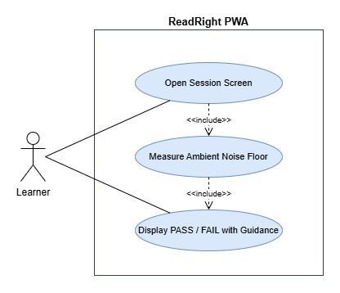

Use Case Description
Use Case ID | UC-1.1
Transaction Name | Ambient Noise Check
Actor | Learner (initiates session); System (performs check automatically)
Preconditions | Learner is authenticated and has navigated to the session screen.  Microphone permission has been granted by the browser.  The getUserMedia audio stream is active.
Main Flow | 1. The system opens the session screen and activates the microphone stream.  2. The system attaches a Web Audio API AnalyserNode to the microphone stream.  3. The system samples the ambient noise floor over a 2-second window before any speech.  4. If the measured noise floor is below the defined threshold, the ambient noise check is marked PASS and a green indicator is displayed to the learner.  5. The system continues monitoring all four GO1 checks in parallel.
Alternate Flow | A1. Noise floor exceeds threshold:  A1.1 The system marks the ambient noise check FAIL.  A1.2 The system displays a plain-language warning: 'Your surroundings are too noisy. Please move to a quieter area.'  A1.3 The recording interface remains disabled.  A1.4 The system re-samples every 2 seconds and updates the indicator automatically when the environment improves.
Postconditions | PASS: The ambient noise indicator is green. The check contributes to the combined GO1 gate (UC-1.5).  FAIL: The ambient noise indicator is red. The recording interface remains disabled until this check passes.
Related SO | The system checks for proper ambient audio conditions, preventing the learner from recording when environment noise is too loud for reliable AI processing.

Wireframe
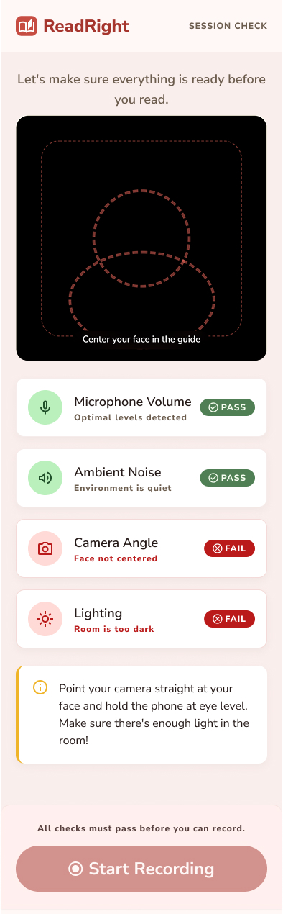

1.2 Ambient Lighting Check

Use Case Diagram
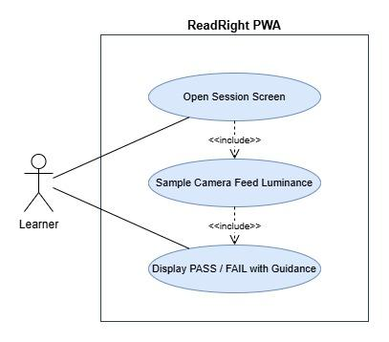

Use Case Description
Use Case ID | UC-1.2
Transaction Name | Ambient Lighting Check
Actor | Learner (initiates session); System (performs check automatically)
Preconditions | Learner is authenticated and has navigated to the session screen.  Camera permission has been granted by the browser.  The getUserMedia video stream is active.
Main Flow | 1. The system draws frames from the live camera stream onto an off-screen canvas element at regular intervals (every 500ms).  2. The system reads per-pixel luminance values from the canvas ImageData.  3. The system computes the average luminance of the frame.  4. If the average luminance meets or exceeds the defined minimum threshold, the lighting check is marked PASS and a green indicator is displayed.  5. The system continues monitoring all four GO1 checks in parallel.
Alternate Flow | A1 Luminance below threshold:  A1.1 The system marks the lighting check FAIL.  A1.2 The system displays a plain-language warning: 'Your face is too dark. Please move to a brighter area or turn on a light.'  A1.3 The recording interface remains disabled.  A1.4 The system re-evaluates every 500ms and updates the indicator automatically when lighting improves.
Postconditions | PASS: The lighting indicator is green. The check contributes to the combined GO1 gate (UC-1.5).  FAIL: The lighting indicator is red. The recording interface remains disabled until this check passes.
Related SO | The system checks ambient lighting via the camera feed before recording begins and notifies the learner if lighting is insufficient for video processing, prompting the learner to adjust their environment.

Wireframe


1.3 Camera Angle Check

Use Case Diagram
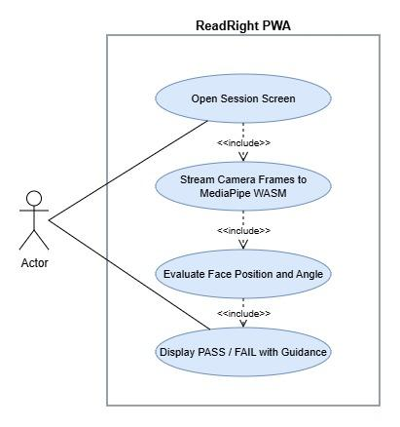

Use Case Description
Use Case ID | UC-1.3
Transaction Name | Camera Angle Check
Actor | Learner (initiates session); System (performs check automatically via MediaPipe WASM)
Preconditions | Learner is authenticated and has navigated to the session screen.  Camera permission has been granted by the browser.  The getUserMedia video stream is active.  MediaPipe Face Mesh WASM module is loaded in the browser.
Main Flow | 1. The system passes live camera frames to the in-browser MediaPipe Face Mesh model.  2. MediaPipe returns facial landmark coordinates for each frame.  3. The system evaluates whether the detected face is within the acceptable center region of the frame and within the acceptable pitch/yaw angle range.  4. If the face is centered and within the acceptable angle range, the camera angle check is marked PASS and a green indicator is displayed.  5. The system continues monitoring all four GO1 checks in parallel.
Alternate Flow | A1 No face detected:  A1.1 The system marks the camera angle check FAIL.  A1.2 The system displays: 'No face detected. Please position your face in front of the camera.'  A2 Face detected but out of position or angle:  A2.1 The system marks the camera angle check FAIL.  A2.2 The system displays directional guidance: 'Please center your face and hold the device at eye level.'  A2.3 The system re-evaluates each frame and updates the indicator automatically.
Postconditions | PASS: The camera angle indicator is green. The check contributes to the combined GO1 gate (UC-1.5).  FAIL: The camera angle indicator is red. The recording interface remains disabled until this check passes.
Related SO | The system checks for proper recording angle before recording begins and guides the learner to the correct camera position.

Wireframe


1.4 Microphone Volume Check

Use Case Diagram
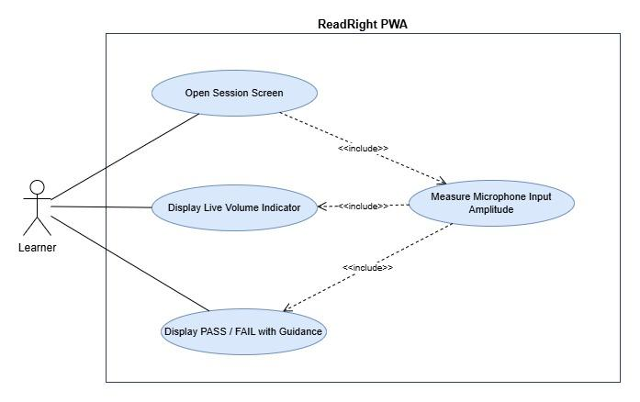

Use Case Description
Use Case ID | UC-1.4
Transaction Name | Microphone Volume Check
Actor | Learner (initiates session, adjusts position if prompted); System (performs check automatically)
Preconditions | Learner is authenticated and has navigated to the session screen.  Microphone permission has been granted by the browser.  The getUserMedia audio stream is active.
Main Flow | 1. The system attaches a Web Audio API AnalyserNode to the microphone stream.  2. The system continuously measures the peak input amplitude of the microphone signal.  3. The system displays a live volume level indicator to the learner.  4. If the measured amplitude is within the acceptable range (above the too-quiet threshold and below the too-loud threshold), the microphone volume check is marked PASS and a green indicator is displayed.  5. The system continues monitoring all four GO1 checks in parallel.
Alternate Flow | A1 Amplitude too low:  A1.1 The system marks the microphone volume check FAIL.  A1.2 The system displays: 'Your microphone is too quiet. Please speak up or move closer to the device.'  A1.3 The recording interface remains disabled.  A2 Amplitude too high:  A2.1 The system marks the microphone volume check FAIL.  A2.2 The system displays: 'Your microphone is too loud. Please move a little further from the device.'  A2.3 The recording interface remains disabled.  A2.4 The system updates the indicator automatically as the learner adjusts.
Postconditions | PASS: The microphone volume indicator is green. The check contributes to the combined GO1 gate (UC-1.5).  FAIL: The microphone volume indicator is red. The recording interface remains disabled until this check passes.
Related SO | The system checks audio volume level before recording begins and displays a warning to the learner if the microphone input is too low or too loud, prompting the learner to adjust before proceeding.

Wireframe


1.5 Recording Interface Gate

Use Case Diagram
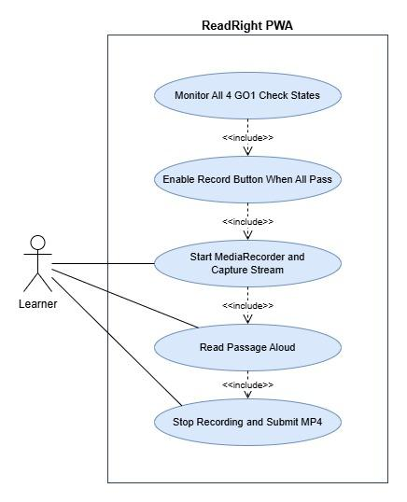

Use Case Description
Use Case ID | UC-1.5
Transaction Name | Recording Interface Gate
Actor | System (evaluates combined check state); Learner (initiates recording once enabled)
Preconditions | All four GO1 quality checks (UC-1.1 through UC-1.4) are actively running.  A Phil-IRI passage has been randomly assigned and is displayed to the learner.
Main Flow | 1. The system continuously evaluates the real-time state of all four GO1 checks.  2. The Record button is rendered in a disabled state while any check is in FAIL state.  3. When all four checks simultaneously reach PASS state, the system enables the Record button and displays a 'Ready to record' confirmation to the learner.  4. The learner taps the Record button to begin the session.  5. The system starts the MediaRecorder, begins capturing the audio and video stream, and stops all GO1 real-time monitoring (AnalyserNode and canvas checks are disconnected).  6. The learner reads the displayed passage aloud.  7. The learner taps Stop when finished.  8. The system finalizes the MP4 recording file and proceeds to submission.
Alternate Flow | A1 A check reverts to FAIL after enabling:  A1.1 If any check reverts to FAIL before the learner taps Record, the system immediately disables the Record button again.  A1.2 The system displays the relevant FAIL indicator and guidance.  A2 Learner attempts to submit without all checks passing:  A2.1 This state cannot occur by design, the submit pathway is only available after recording completes, and recording cannot start without all checks passing.
Postconditions | Recording started: The MP4 recording session is underway. GO1 monitoring is inactive during recording.  Recording complete: A valid MP4 file is ready for submission to the FastAPI AI microservice.
Related SO | The system enables the recording interface only when all four quality checks pass simultaneously, and prevents submission if any check has not been satisfied.

Activity Diagram
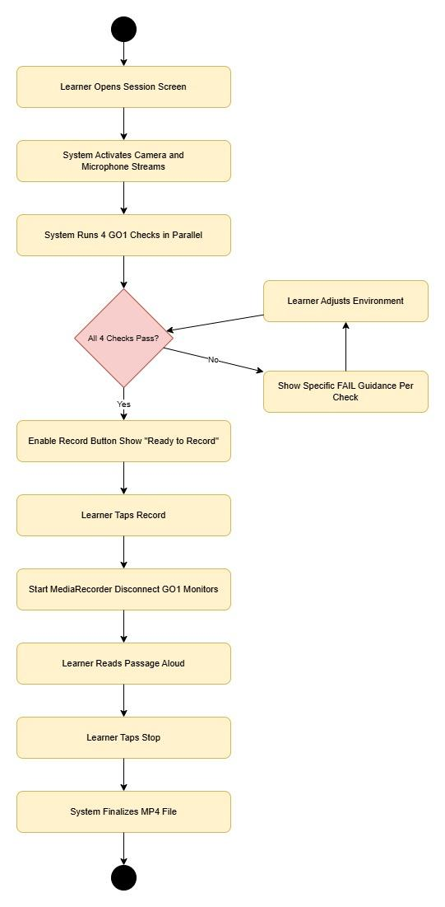

Wireframe
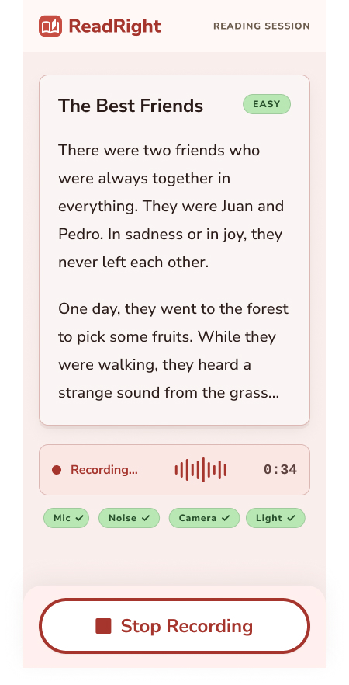

Module 2

2.1 Audio Transcription and Forced Alignment

Use Case Diagram
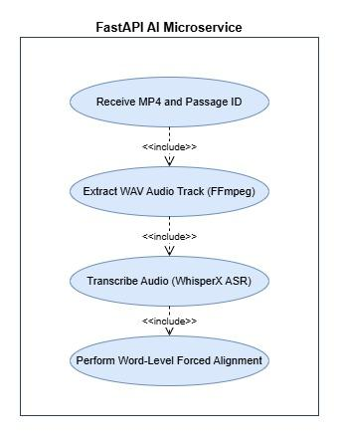

Use Case Description
Use Case ID | UC-2.1
Transaction Name | Audio Transcription and Forced Alignment
Actor | System (fully automated, no learner interaction after submission)
Preconditions | The learner has submitted a valid MP4 recording that passed GO1 quality checks.  The FastAPI AI microservice has received the POST /analyze request with the MP4 file and passage_id.  The target passage text is retrievable from the passage bank using the passage_id.
Main Flow | 1. FastAPI receives the MP4 file and passage_id.  2. FFmpeg extracts the audio-only track from the MP4 as a WAV file.  3. WhisperX transcribes the WAV audio, producing a raw transcript.  4. WhisperX performs forced alignment between the transcript and the target passage text, producing a word-level alignment object with start timestamp, end timestamp, and transcribed form for every word in the passage.  5. The alignment object is passed to the miscue classifier (UC-2.2).
Alternate Flow | A1 WhisperX transcription fails (unintelligible audio):  A1.1 FastAPI logs the error and returns HTTP 500 with error code TRANSCRIPTION_FAILED.  A1.2 The frontend displays: 'We could not process your recording. Please re-record in a quieter environment.'  A2 Forced alignment produces incomplete output (missing words):  A2.1 FastAPI logs the alignment gap and treats missing words as omissions before passing to the classifier.
Postconditions | A word-level alignment object is produced containing every passage word mapped to its transcribed form and timestamps.  This object is passed to UC-2.2 for miscue classification.
Related SO | The system transcribes the audio and performs forced alignment against the target passage, producing a word-level mapping with timestamps for every word in the passage.

Activity Diagram
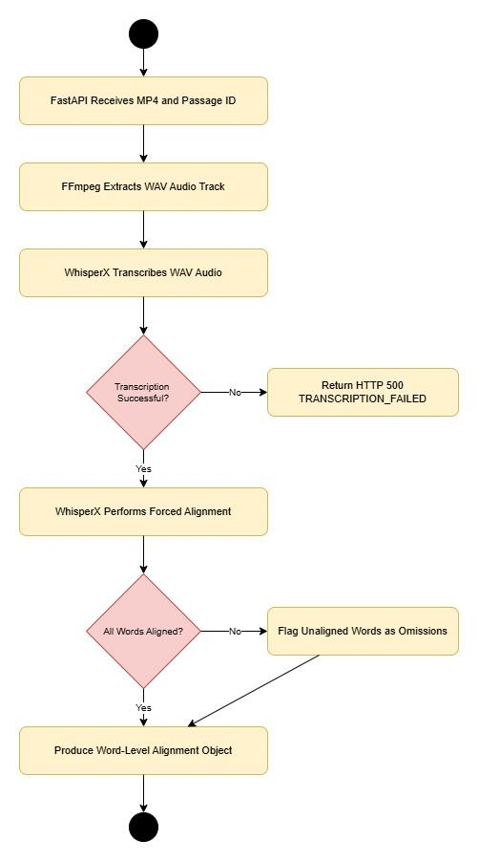

Wireframe
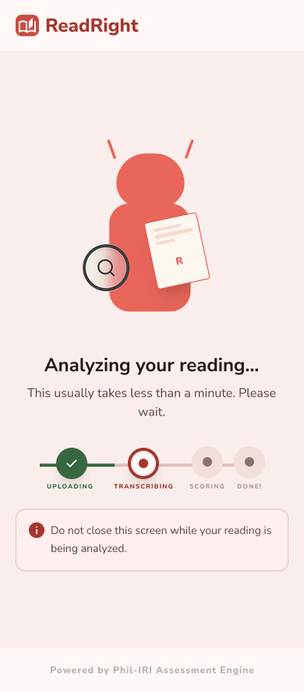

2.2 Phil-IRI Miscue Classification

Use Case Diagram
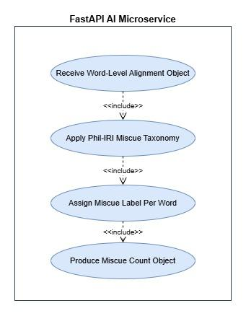

Use Case Description
Use Case ID | UC-2.2
Transaction Name | Phil-IRI Miscue Classification
Actor | System (fully automated)
Preconditions | UC-2.1 has completed successfully.  A word-level alignment object is available, mapping each target passage word to its transcribed form and timestamps.
Main Flow | 1. The rule-based miscue classifier receives the word-level alignment object.  2. For each word in the target passage, the classifier applies the Phil-IRI miscue taxonomy:  - Correct: transcribed form exactly matches target word.  - Mispronunciation: transcribed form is phonetically similar but not the target word.  - Substitution: a different real word was read in place of the target word.  - Omission: the word has no corresponding transcribed output (flagged in UC-2.1).  - Insertion: an extra word appears in the transcript not present in the target passage.  - Repetition: the same word or phrase appears more than once in the aligned transcript.  - Refusal to Pronounce: a long silence (above defined pause threshold) with no transcribed output for a word.  3. The classifier produces a per-word label for every passage word and a count for each of the seven miscue categories.  4. The miscue count object is passed to UC-2.3.
Alternate Flow | A1 Word cannot be unambiguously classified:  A1.1 The classifier applies the most conservative label (defaults to Mispronunciation over Substitution when phonetic similarity is ambiguous).  A1.2 The classification proceeds without interruption.
Postconditions | Every passage word has a Phil-IRI miscue label.  A miscue count object with seven integer fields is produced and passed to UC-2.3.
Related SO | The system applies the Phil-IRI miscue taxonomy to the forced alignment output, classifying each word as correct, mispronunciation, substitution, omission, insertion, repetition, or refusal to pronounce.

Activity Diagram
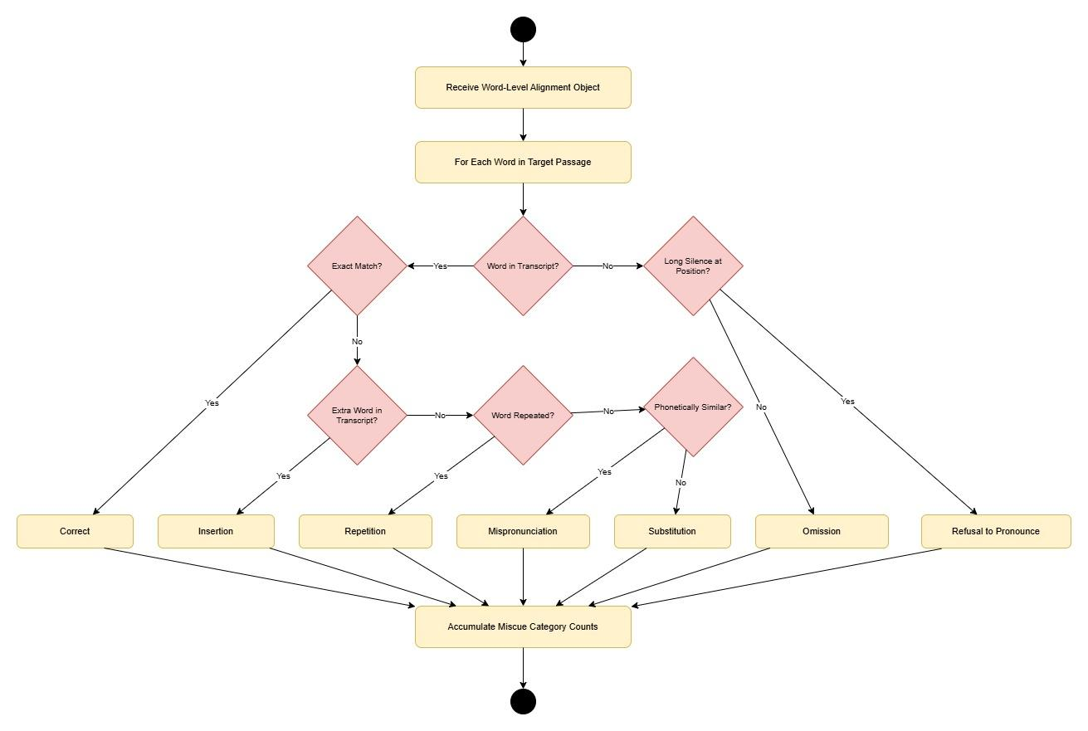

Wireframe


2.3 WPM and Word Recognition Percentage Computation

Use Case Diagram
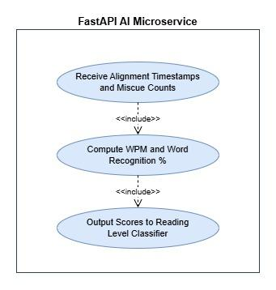

Use Case Description
Use Case ID | UC-2.3
Transaction Name | WPM and Word Recognition Percentage Computation
Actor | System (fully automated)
Preconditions | UC-2.1 has produced a word-level alignment object with timestamps.  UC-2.2 has produced a miscue count object with seven category counts.
Main Flow | 1. The scoring engine retrieves the start timestamp of the first correctly aligned word and the end timestamp of the last word in the passage.  2. The system computes total reading time in minutes: (end_timestamp - start_timestamp) / 60.  3. The system computes WPM: total passage word count / total reading time in minutes.  4. The system computes the number of correctly read words: total passage words minus omissions, substitutions, mispronunciations, and refusals to pronounce. Insertions and repetitions are not deducted from the correct word count per Phil-IRI scoring rules.  5. The system computes word recognition percentage: (correctly read words / total passage words) × 100.  6. Both computed values (WPM as float, word recognition % as float) are passed to UC-2.4.
Alternate Flow | A1 Reading time is zero or near-zero (corrupt timestamps):  A1.1 FastAPI returns HTTP 500 with error code SCORING_FAILED.  A1.2 The frontend displays a re-record prompt to the learner.
Postconditions | WPM (float) and word recognition percentage (float) are computed and passed to UC-2.4 for reading level classification.
Related SO | The system computes WPM from the forced alignment timestamps of spoken words and word recognition percentage from miscue classification output.

Wireframe


2.4 Phil-IRI Reading Level Classification

Use Case Diagram
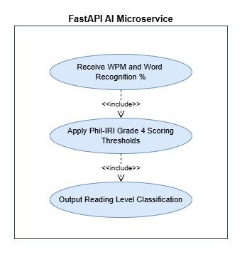

Use Case Description
Use Case ID | UC-2.4
Transaction Name | Phil-IRI Reading Level Classification
Actor | System (fully automated)
Preconditions | UC-2.3 has produced valid WPM and word recognition percentage values.
Main Flow | 1. The Phil-IRI classifier receives WPM and word recognition percentage.  2. The classifier applies the Phil-IRI Grade 4 scoring thresholds to the word recognition percentage:  - Independent: word recognition ≥ 97%  - Instructional: word recognition 91–96%  - Frustration: word recognition ≤ 90%  3. The classifier applies the Phil-IRI Grade 4 WPM benchmarks as a secondary signal to confirm the classification.  4. The classifier outputs a reading level classification string: 'Independent', 'Instructional', or 'Frustration'.  5. The complete GO2 output, WPM; word recognition %, reading level classification, and miscue count object, is consolidated into the assessment result JSON.  6. The assessment result is held pending completion of the parallel GO3 pipeline (UC-3.1 and UC-3.2) before the final JSON is returned to the frontend.
Alternate Flow | A1 Word recognition percentage is exactly on a boundary:  A1.1 The classifier applies the lower classification (conservative approach consistent with Phil-IRI protocol).
Postconditions | A reading level classification string is produced.  The complete GO2 assessment output is consolidated and held for merge with GO3 behavioral flags before returning to the frontend.
Related SO | The system applies Phil-IRI scoring thresholds to the computed scores and produces a reading level classification of frustration, instructional, or independent for every valid submission.

Wireframe


Module 3

3.1 Computer Vision Behavioral Detection

Use Case Diagram
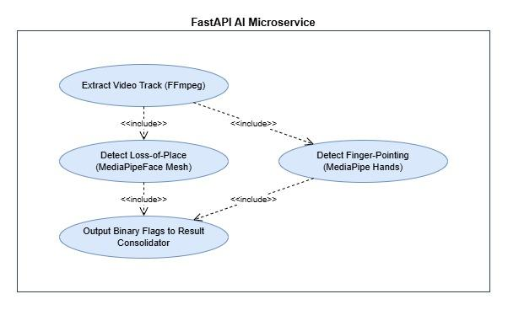

Use Case Description
Use Case ID | UC-3.1
Transaction Name | Computer Vision Behavioral Detection
Actor | System (fully automated; runs in parallel with GO2 pipeline)
Preconditions | The FastAPI microservice has received the MP4 recording file.  FFmpeg is available in the microservice environment.  MediaPipe Hands and Face Mesh models are loaded in the microservice environment.
Main Flow | 1. FFmpeg extracts the video-only track from the submitted MP4 as a separate video file.  2. The video file is processed frame-by-frame by MediaPipe.  3. For finger-pointing detection: MediaPipe Hands analyzes each frame for the presence of an extended index finger positioned near or below the text area of the frame. If detected in any frame, finger_pointing is set to True.  4. For loss-of-place detection: MediaPipe Face Mesh tracks iris landmark positions frame-by-frame. Abrupt lateral or vertical gaze shifts of magnitude exceeding the defined threshold are counted. If the count exceeds the defined frequency threshold, loss_of_place is set to True.  5. Both binary flags are produced and passed to the GO3 result consolidator.
Alternate Flow | A1 No face detected in video (learner moved out of frame):  A1.1 loss_of_place is set to True (conservative, untrackable gaze is treated as a potential loss-of-place event).  A2 No hands detected throughout the video:  A2.1 finger_pointing is set to False.  A3 Video track is corrupt or unreadable:  A3.1 FastAPI logs the error. Both flags are set to null and the session is flagged for manual review.
Postconditions | Two binary flags are produced: finger_pointing (boolean) and loss_of_place (boolean).  Flags are passed to the GO3 result consolidator for merge with GO2 output.
Related SO | The system detects finger-pointing and loss-of-place eye movements from student's reading videos using computer vision analysis via MediaPipe, producing a binary flag per behavior.

Activity Diagram
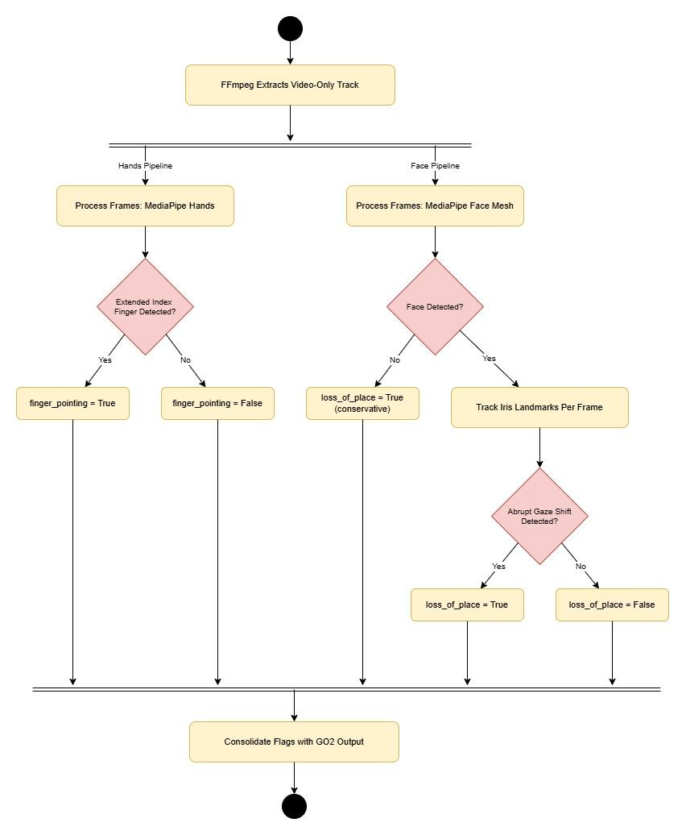

Wireframe


3.2 Prosody and Amplitude Behavioral Detection

Use Case Diagram
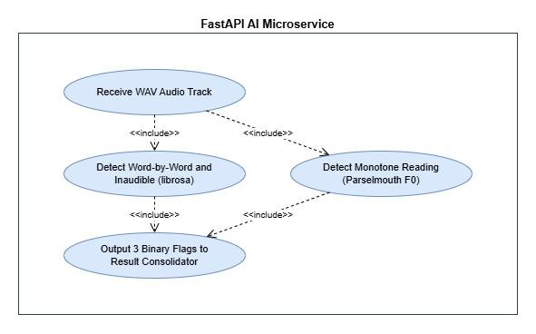

Use Case Description
Use Case ID | UC-3.2
Transaction Name | Prosody and Amplitude Behavioral Detection
Actor | System (fully automated; runs in parallel with GO2 pipeline)
Preconditions | The FastAPI microservice has received the MP4 recording file.  FFmpeg has extracted the WAV audio track (shared with GO2 pipeline, no duplicate extraction).  librosa and Parselmouth are available in the microservice environment.
Main Flow | 1. The WAV audio file is passed to both librosa and Parselmouth.  2. Monotone reading detection (Parselmouth): Parselmouth extracts the fundamental frequency (F0) contour across the full recording. The system computes the standard deviation of F0. If the standard deviation falls below the defined pitch variation threshold, monotone_reading is set to True.  3. Word-by-word reading detection (librosa): librosa performs onset detection to identify word boundaries and inter-word silence durations. If the mean inter-word pause duration exceeds the defined threshold, word_by_word_reading is set to True.  4. Inaudible reading detection (librosa): librosa computes the root-mean-square (RMS) energy of the audio signal across the full recording. If the mean RMS energy falls below the defined amplitude threshold, inaudible_reading is set to True.  5. All three binary flags are produced and passed to the GO3 result consolidator.
Alternate Flow | A1 Audio is too short for reliable F0 extraction:  A1.1 monotone_reading is set to False (insufficient data, conservative default).  A2 No speech detected (flat silence throughout):  A2.1 inaudible_reading is set to True.  A2.2 monotone_reading and word_by_word_reading are set to False (cannot be determined from silence).
Postconditions | Three binary flags are produced: monotone_reading (boolean), word_by_word_reading (boolean), and inaudible_reading (boolean).  All five GO3 behavioral flags (including UC-3.1 outputs) are consolidated and merged with the GO2 assessment result.  The complete assessment result JSON is returned to the frontend.
Related SO | The system detects monotone reading, word-by-word reading, and inaudible voice from student's audio recordings using prosody analysis via librosa and Parselmouth, producing a binary flag per behavior.

Wireframe


Module 4

4.1 Session Results Display

Use Case Diagram
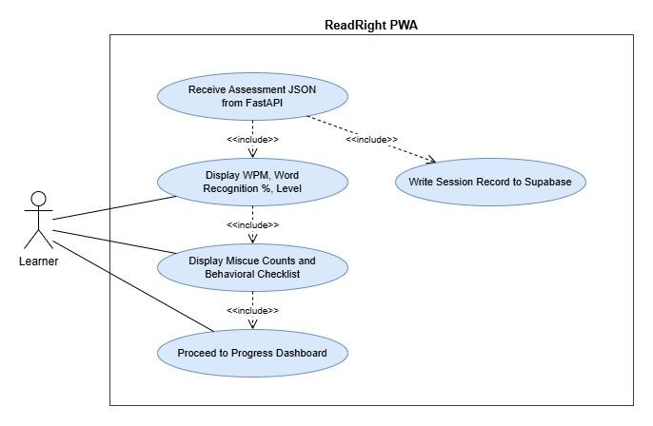

Use Case Description
Use Case ID | UC-4.1
Transaction Name | Session Results Display
Actor | System (renders results); Learner (views results)
Preconditions | The FastAPI AI microservice has returned a complete assessment result JSON to the frontend.  The learner is authenticated and their Supabase JWT is valid.
Main Flow | 1. The frontend receives the assessment result JSON from FastAPI.  2. The frontend writes the complete session record to Supabase using the learner's authenticated JWT (INSERT into sessions table).  3. The frontend navigates the learner to the Session Results page.  4. The Session Results page displays:  a. WPM value with a plain-language label (e.g., 'Words per minute').  b. Word recognition percentage with a plain-language label.  c. Phil-IRI reading level classification badge (Frustration / Instructional / Independent) with a plain-language explanation of what the level means for the learner's reading.  d. Miscue type counts displayed as a labeled breakdown (e.g., 'Mispronunciations: 3').  e. Behavioral checklist displaying each of the five Phil-IRI qualitative behaviors as a checked or unchecked item, framed as reading habits to be aware of.  5. The learner can tap a button to proceed to their Personal Progress Dashboard.
Alternate Flow | A1 Supabase write fails:  A1.1 The frontend retries the INSERT up to 3 times.  A1.2 If all retries fail, the frontend displays the session results to the learner as normal but shows a warning: 'Your result may not have been saved. Please check your connection.'  A2 FastAPI returned an error JSON:  A2.1 The frontend does not navigate to the Session Results page.  A2.2 The frontend displays a plain-language error and prompts the learner to re-record.
Postconditions | The learner has viewed their complete Phil-IRI assessment output for the session.  The session record is persisted in Supabase (barring the A1 alternate flow).  The learner can proceed to the Personal Progress Dashboard.
Related SO | The system displays a summary of the assessment output, WPM, word recognition percentage, reading level classification, miscue type counts, and behavioral checklist, to the learner upon completion of AI processing, alongside plain-language fluency feedback explaining what the result means for their reading improvement.

Wireframe
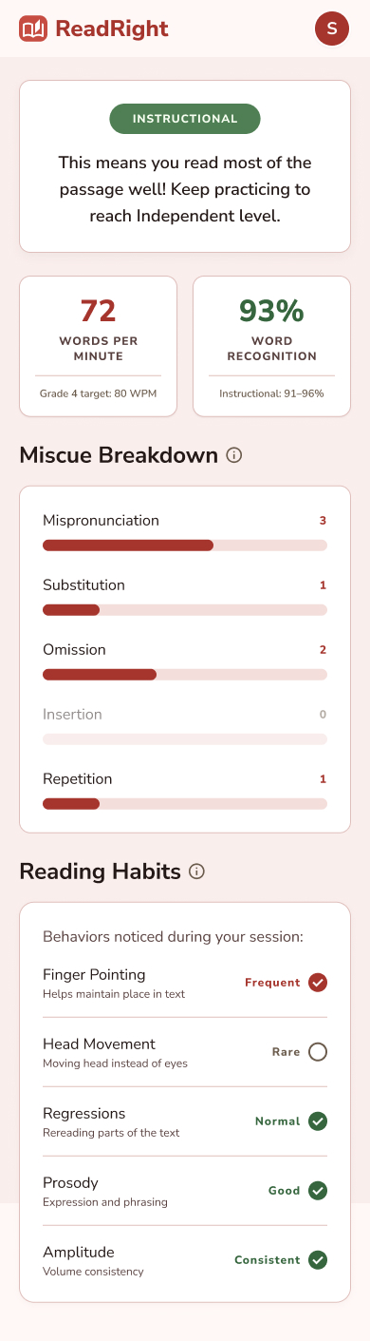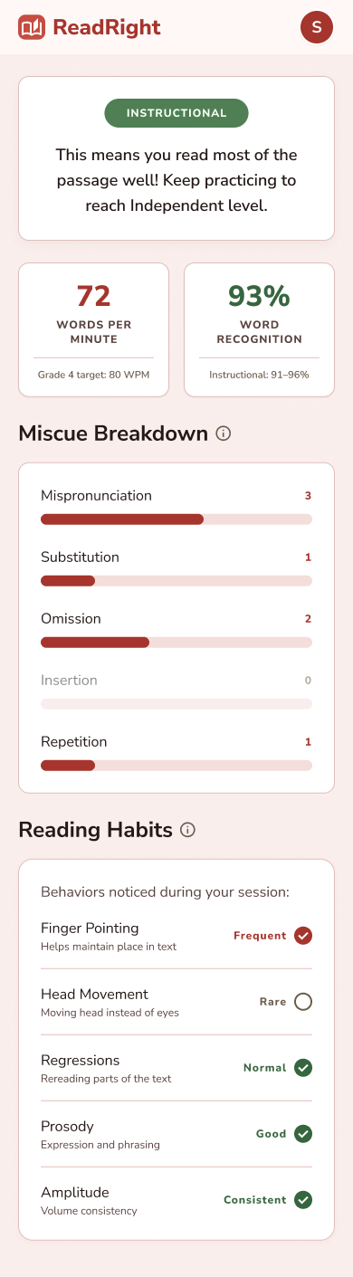

4.2 Session Record Storage

Use Case Diagram
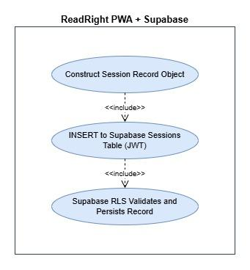

Use Case Description
Use Case ID | UC-4.2
Transaction Name | Session Record Storage
Actor | System (performs write); Supabase RLS (enforces data isolation)
Preconditions | The assessment result JSON has been received from FastAPI.  The learner is authenticated and their JWT is valid.  The Supabase sessions table has RLS enabled with a policy restricting writes to the authenticated learner's own user ID.
Main Flow | 1. The frontend constructs a session record object from the assessment result JSON, adding the learner's user ID (from the Supabase JWT), session timestamp, and passage ID.  2. The frontend calls the Supabase PostgREST INSERT endpoint for the sessions table, passing the session record and the learner's JWT as a Bearer token.  3. Supabase RLS validates that the learner's user ID in the record matches the JWT's subject claim.  4. Supabase writes the record to the PostgreSQL sessions table.  5. Supabase returns a success confirmation to the frontend.  6. The frontend proceeds to render the Session Results page (UC-4.1).
Alternate Flow | A1 RLS policy rejects the write (user ID mismatch):  A1.1 Supabase returns HTTP 403.  A1.2 The frontend logs the error and attempts to re-authenticate the learner.  A2 Network failure during write:  A2.1 The frontend retries up to 3 times with exponential backoff.  A2.2 If all retries fail, the frontend proceeds to display session results and shows a save-failure warning.
Postconditions | The session record is persisted in Supabase and available for retrieval by the Personal Progress Dashboard (UC-4.3 and UC-4.4) across all future sessions.
Related SO | The system stores all session results per learner in a structured database, making records available for retrieval across the full school year without requiring the learner to maintain separate records.

4.3 Reading Level Trend and WPM Progression Charts

Use Case Diagram
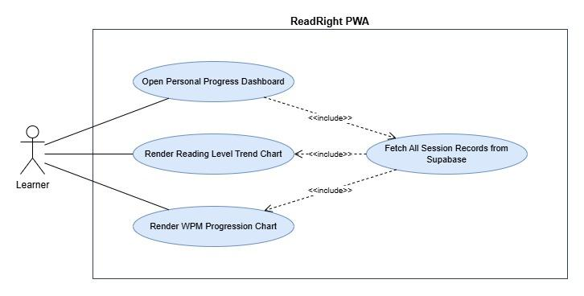

Use Case Description
Use Case ID | UC-4.3
Transaction Name | Reading Level Trend and WPM Progression Charts
Actor | Learner (views dashboard); System (retrieves and renders data)
Preconditions | The learner is authenticated.  At least one confirmed session record exists in Supabase for this learner.  The learner has navigated to the Personal Progress Dashboard.
Main Flow | 1. The frontend issues a SELECT query to Supabase for all session records belonging to the authenticated learner, ordered by session timestamp ascending.  2. Supabase RLS validates the JWT and returns only the learner's own session records.  3. The frontend renders a Reading Level Trend chart: a line or step chart showing the learner's Phil-IRI reading level classification (Frustration / Instructional / Independent, mapped to numeric values for charting) across all sessions, with session date on the x-axis.  4. The frontend renders a WPM Progression chart: a line chart showing the learner's WPM value across all sessions, with session date on the x-axis and Phil-IRI Grade 4 WPM benchmark lines displayed for reference.  5. Both charts are displayed on the Personal Progress Dashboard.
Alternate Flow | A1 No session records exist yet:  A1.1 The dashboard displays an empty state message: 'Complete your first session to see your progress here.'  A2 Supabase returns an error:  A2.1 The dashboard displays: 'Unable to load your progress. Please check your connection and try again.'
Postconditions | The learner can view their reading level trend and WPM progression across all completed sessions, with Phil-IRI Grade 4 benchmarks displayed for reference.
Related SO | The learner can view a reading level trend chart showing their Phil-IRI classification across all completed sessions and a WPM progression chart showing their speed improvement, with grade-level benchmarks displayed for reference.

Wireframe
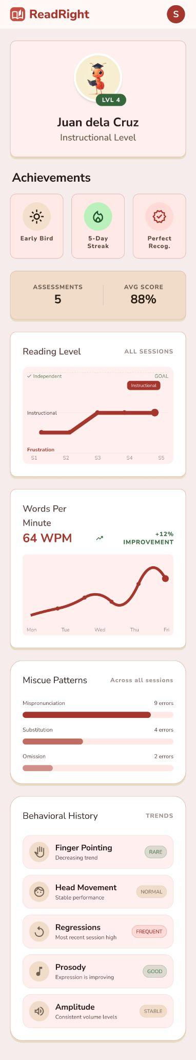

4.4 Miscue Breakdown and Behavioral History Display

Use Case Diagram
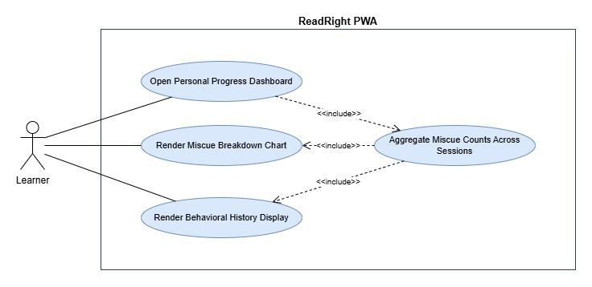

Use Case Description
Use Case ID | UC-4.4
Transaction Name | Miscue Breakdown and Behavioral History Display
Actor | Learner (views dashboard); System (retrieves and renders data)
Preconditions | The learner is authenticated.  At least one confirmed session record exists in Supabase for this learner.  The session data has already been fetched in UC-4.3 (shared fetch, no duplicate query).
Main Flow | 1. The frontend uses the session records already retrieved in UC-4.3.  2. The frontend aggregates miscue counts across all sessions by category (mispronunciation, substitution, omission, insertion, repetition, refusal to pronounce) and renders a Miscue Breakdown chart showing the distribution of miscue types across the learner's full session history.  3. The frontend renders a Behavioral History section displaying each of the five Phil-IRI qualitative behaviors as a row, with a visual indicator (e.g., flagged count or session-by-session checklist) showing how frequently each behavior was flagged across the learner's sessions.  4. Both components are displayed on the Personal Progress Dashboard alongside the charts from UC-4.3.
Alternate Flow | A1 No session records exist yet:  A1.1 The dashboard displays the same empty state as UC-4.3.  A2 All miscue counts are zero across all sessions:  A2.1 The miscue breakdown chart displays a zero state with a message: 'No miscues detected across your sessions.'
Postconditions | The learner can view their miscue type distribution and behavioral flag history across all completed sessions, giving them a longitudinal view of reading habits and areas for improvement.
Related SO | The learner can view a miscue type breakdown chart showing the distribution of miscue categories across all completed sessions, and a behavioral history checklist showing which Phil-IRI qualitative behaviors were flagged across sessions.

Wireframe


Non-functional requirements

Performance

NFR-P1 AI Pipeline Processing Time
The system must complete the full AI processing pipeline; from the moment the FastAPI microservice receives the complete MP4 file to the moment the frontend displays the Session Results page; within 90 seconds for any valid recording of up to 3 minutes in length. This window covers FFmpeg track extraction, parallel execution of the GO2 audio pipeline (WhisperX transcription, forced alignment, miscue classification, WPM computation, and reading level classification) and the GO3 video and prosody pipelines (MediaPipe CV detection, Parselmouth F0 analysis, librosa onset and amplitude analysis), JSON response transmission, Supabase session record write, and frontend result rendering.
Recording upload time is explicitly excluded from this requirement, as upload duration is dependent on the learner's home network speed and is outside the system's control. The frontend must display a 'Processing your recording…' indicator for the full duration of the wait and must not time out the request before the 90-second window has elapsed.
- Target: ≤ 60 seconds for recordings up to 2 minutes in length under normal server load.
- Maximum: ≤ 90 seconds for recordings up to 3 minutes in length under peak server load.
- Breach condition: If the pipeline has not returned a result within 120 seconds, the frontend must display a timeout error and offer the learner the option to re-record or retry submission. The 120-second frontend request timeout defined in Section 3.1.3 provides the enforcement mechanism for this ceiling.

NFR-P2 GO1 Quality Check Responsiveness
The four GO1 pre-recording quality checks (ambient noise, ambient lighting, camera angle, and microphone volume) run in real time in the browser before recording begins. Each check must update its pass/fail indicator within 1 second of a change in the learner's environment. The combined GO1 gate (UC-1.5) must enable the Record button within 1 second of all four checks simultaneously reaching PASS state.
- The Web Audio API AnalyserNode must sample at a minimum interval of 500ms for the noise and volume checks.
- The Canvas API luminance check must re-evaluate at a minimum interval of 500ms.
- The MediaPipe Face Mesh camera angle check must re-evaluate on each new video frame at the stream's native frame rate (minimum 15fps).

NFR-P3 Dashboard and Results Page Load Time
The Session Results page must render completely within 3 seconds of the frontend receiving the assessment result JSON from FastAPI, assuming the Supabase session record write completes successfully. The Personal Progress Dashboard must load and render all charts within 5 seconds of the learner navigating to it, assuming a stable network connection and a session history of up to 50 completed sessions.
- Supabase SELECT queries for dashboard data must use indexed columns (learner user ID and session timestamp) to meet this load time requirement as session history grows.

NFR-P4 PWA Initial Load Time
The ReadRight PWA must achieve an initial page load and become interactive within 5 seconds on a mid-range Android smartphone (equivalent to approximately 4× CPU throttling relative to desktop) on a 4G LTE connection. Subsequent loads after the Service Worker is registered must be faster due to asset caching, though the system has no offline functionality.
- The React production build must be optimized with code splitting and lazy loading for non-critical routes (e.g., the dashboard is not bundled with the session recording interface).
- TailwindCSS must be configured with PurgeCSS in the production build to eliminate unused utility classes from the final bundle.

Security

NFR-S1 Learner Data Privacy for Minors (RA 10173 Compliance)
All learner data collected and stored by ReadRight; including account credentials, session records, assessment results, and audio/video recordings, is subject to the Philippine Data Privacy Act of 2012 (Republic Act 10173). Because the target users are minors (approximately 9–10 years old), the system must apply heightened data protection measures consistent with the standards applicable to children's personal data.
- Learner accounts must require only the minimum personal data necessary for system function. No data beyond what is required for authentication and progress tracking may be collected.
- All recordings submitted to the FastAPI AI microservice must be treated as temporary processing inputs. Recordings must be deleted from FastAPI server storage immediately upon pipeline completion. No recording file may be retained on the microservice host beyond the processing window.
- Session records and assessment results stored in Supabase are retained for the duration of the pilot deployment and must not be shared with third parties.

NFR-S2 HTTPS and Transport Security
All communication between the learner's browser and all external services must be conducted over HTTPS with TLS 1.2 or higher, as specified in Section 3.1.3. This requirement is non-negotiable and applies to both the React PWA frontend host and the FastAPI AI microservice endpoint. Any deployment configuration that serves either endpoint over plain HTTP must be treated as a critical security defect.
- The TLS certificate for the FastAPI microservice host must be a valid, unexpired certificate from a trusted Certificate Authority. Self-signed certificates are not acceptable for pilot deployment.
- HTTP Strict Transport Security (HSTS) headers must be configured on the PWA frontend host to prevent protocol downgrade attacks.

NFR-S3 Authentication and JWT Handling
Learner authentication is managed exclusively by Supabase Auth. The system must handle JWT tokens in accordance with the following security requirements:
- JWT access tokens must be stored in browser memory (managed by the Supabase JS SDK) and must not be persisted to localStorage, sessionStorage, or any browser-accessible storage mechanism that survives page reload.
- The Supabase JS SDK's automatic token refresh mechanism must be enabled to prevent session expiry during active use.
- The FastAPI AI microservice must not receive or process the learner's JWT. The microservice accepts only the MP4 recording file and passage ID, with no user identity information transmitted.
- Failed login attempts must be handled by Supabase Auth's built-in rate limiting. The frontend must not implement custom authentication logic that bypasses Supabase Auth.

NFR-S4 Supabase Row-Level Security (RLS)
Row-Level Security must be enabled on all learner-facing tables in the Supabase PostgreSQL database before pilot deployment. RLS policies must enforce the following access rules:
- A learner may only SELECT, INSERT, and UPDATE rows where the user_id column matches the user ID claim in their authenticated JWT.
- No learner may read, modify, or delete another learner's session records, assessment results, or progress data under any circumstance.
- RLS must be verified through functional testing before pilot deployment. A test confirming that a learner's JWT cannot retrieve another learner's records must be included in the validation study.

NFR-S5 FastAPI Microservice Access Control
The FastAPI AI microservice /analyze endpoint processes learner recordings and must not be publicly accessible without access controls. The following minimum access control measures must be implemented before pilot deployment:
- A static API key header (e.g., X-API-Key) must be required on all requests to the /analyze endpoint. The key must be stored as an environment variable in the React frontend build and must not be committed to version control.
- The microservice must reject requests that do not include the correct API key with an HTTP 401 response.
- The API key must be rotated if the frontend repository is made public or if a security incident is suspected.

Reliability

NFR-R1 AI Pipeline Completeness Rate
The system must produce a complete Phil-IRI assessment output, miscue classification, WPM, word recognition percentage, reading level classification, and all five behavioral binary flags; for 100% of recordings that pass the GO1 quality gate and are successfully uploaded to the FastAPI microservice. A complete output is defined as a JSON response containing all required fields with no null or missing values.
- A session is considered a pipeline failure only if FastAPI returns an HTTP 500 error or if the JSON response is missing one or more required fields. Network failures during upload are not counted as pipeline failures.
- Pipeline failures must be logged by the FastAPI microservice with sufficient detail (error type, pipeline stage, recording duration) to support debugging during the validation study.
- This requirement corresponds directly to the GO2 measurability criterion: 100% of valid recordings produce a complete output with no missing fields.

NFR-R2 GO1 Input Quality Acceptance Rate
The GO1 quality verification module must achieve an acceptance rate of at least 90% across all session attempts during the pilot deployment. This means that at least 90% of learner session attempts must result in a recording that passes all four GO1 checks and is successfully submitted to the AI pipeline without requiring the learner to abandon the session due to persistent quality check failures.
- Sessions abandoned due to persistent GO1 failures (learner closes the app or navigates away without successfully recording) are counted against this rate.
- The acceptance rate must be measured and reported as part of the system validation study.

NFR-R3 Data Persistence and No Data Loss
All confirmed session records must be persisted to Supabase without data loss. A confirmed session record is defined as any session for which the AI pipeline has returned a complete JSON result and the frontend has received it.
- The frontend must retry failed Supabase INSERT operations up to 3 times with exponential backoff before presenting a save-failure warning to the learner, as specified in UC-4.2.
- The Personal Progress Dashboard must display all confirmed session records correctly, with no missing or incorrectly attributed records, across the full pilot deployment period.
- Session records must not be deleted, overwritten, or corrupted by concurrent sessions from the same learner account.

NFR-R4 System Availability
The ReadRight system including the React PWA frontend, Supabase auth and database services, and FastAPI AI microservice; must maintain a combined availability of at least 95% during the pilot deployment period. Availability is defined as the proportion of time during which a learner can successfully complete a full session (log in, record, receive results, and view the dashboard) without encountering a system-level failure.
- Planned maintenance windows, if any, must be scheduled outside peak usage hours and communicated to the pilot school in advance.
- Supabase's managed infrastructure contributes to this availability target; the team is responsible for maintaining the FastAPI microservice host and PWA frontend host uptime.
- Unplanned downtime exceeding 5% of the pilot deployment period must be documented as a system limitation in the validation study report.

NFR-R5 Graceful Error Handling and Recovery
The system must handle all anticipated failure conditions gracefully, without crashing the application or leaving the learner in an unrecoverable state. For every error condition identified in the alternate flows of the functional requirements (Sections 3.2), the system must display a plain-language error message appropriate for a 9–10 year old learner and provide a clear recovery action.
- AI pipeline failures: The learner is shown an error message and offered the option to re-record the session. No partial or corrupted assessment data is displayed.
- Supabase write failures: The Session Results page is still displayed to the learner. A save-failure warning is shown. The learner's in-session result is not lost even if the database write fails.
- Network timeout during processing: The frontend displays a timeout message after 120 seconds and offers retry options. The learner is not left on a blank or frozen screen.
- GO1 persistent failures: The learner is shown specific guidance for each failing check. The session cannot begin, but the learner is not locked out of the application.

Usability

NFR-U1 Age-Appropriate Interface Design
The ReadRight interface must be designed and validated for independent use by Filipino Grade 4 learners aged approximately 9–10 years old, with minimal or no adult assistance required during a session. The following design requirements apply to all learner-facing screens:
- All instructional text, error messages, quality check guidance, and result feedback must be written in plain, age-appropriate Filipino English. Technical terms (e.g., 'miscue', 'forced alignment', 'ASR') must not appear in any learner-facing text. Reading level classification results must be presented with plain-language explanations (e.g., 'This means you are reading comfortably at Grade 4 level').
- Body text on all learner-facing screens must use a minimum font size of 16px (12pt equivalent) on mobile viewports. Passage display text must use a minimum font size of 18px to support comfortable oral reading by a 9–10 year old.
- All interactive elements (buttons, toggles, form fields) must have a minimum touch target size of 44×44 pixels, consistent with iOS Human Interface Guidelines and Android Material Design accessibility recommendations.
- The number of steps required to complete a session from login to viewing results must not exceed 5 distinct learner actions: (1) log in, (2) pass GO1 checks, (3) tap Record, (4) tap Stop, (5) view results.

NFR-U2 GO1 Quality Check Guidance Clarity
The GO1 quality check feedback displayed to the learner must be specific, actionable, and unambiguous. A learner who has never used the system before must be able to understand and resolve any GO1 FAIL condition without adult assistance.
- Each failing check must display a single, specific instruction (e.g., 'Move to a quieter room' for noise, 'Turn on a light or face a window' for lighting, 'Hold the phone at eye level' for camera angle, 'Speak a little louder' for microphone volume). Generic error messages such as 'Check failed' or 'Error' are not acceptable.
- Visual pass/fail indicators must use colour (green for PASS, red or amber for FAIL) combined with an icon or label, not colour alone, to ensure accessibility for learners with colour vision deficiencies.

NFR-U3 Session Results Plain-Language Feedback
The Session Results page (UC-4.1) must present the Phil-IRI assessment output in a format that is meaningful and actionable for a 9–10 year old learner reading independently. Numerical scores must be accompanied by plain-language interpretations.
- The reading level classification (Frustration / Instructional / Independent) must be presented with a brief explanation of what each level means for the learner's reading (e.g., 'Frustration level means this passage was very challenging. Keep practising!'). The label alone is not sufficient.
- The behavioral checklist must frame each detected behavior as a reading habit to improve, not as a failure or penalty. Framing such as 'You pointed at words while reading; try reading without your finger next time' is required. Framing such as 'FAILED: Finger pointing detected' is not acceptable.
- WPM and word recognition percentage must be displayed with grade-level context (e.g., 'Grade 4 target: X WPM') so the learner understands their score relative to the standard.

NFR-U4 Learnability for First-Time Users
A first-time learner must be able to complete their first session successfully without requiring external instruction beyond what is provided within the application itself. The system must not assume prior experience with reading assessment tools, web applications, or browser media permissions.
- The first session flow must include inline onboarding instructions explaining what the learner is about to do, why GO1 checks are necessary, and what will happen after they record.
- Camera and microphone permission prompts must be preceded by an in-app explanation of why permissions are needed, so the learner is not surprised by the browser's native permission dialogue.
- The passage display screen must include a brief instruction (e.g., 'Read this passage aloud, clearly and at your normal pace') visible to the learner before and during recording.

Compatibility

NFR-C1 Supported Browsers and Operating Systems
ReadRight must function correctly on the following browser and operating system combinations, which represent the expected device population of the pilot school learners and their households:
- Chrome for Android (latest two major versions) on Android 10 or higher: Primary target platform. All features including getUserMedia, MediaRecorder (video/webm), Service Worker, and PWA installation must function correctly.
- Safari for iOS (latest two major versions) on iOS 16.4 or higher: Required for PWA home screen installation support (added in iOS 16.4). MediaRecorder on iOS Safari produces audio/mp4 only; the system must handle this codec correctly as specified in Section 3.1.2. iOS versions below 16.4 do not support PWA installation and are not a supported target.
- Chrome for desktop (latest two major versions) on Windows 10 or higher: Secondary target for learners using home computers. Full feature support required.
- Edge for desktop (latest two major versions) on Windows 10 or higher: Secondary target. Full feature support required.
- Safari for macOS (latest two major versions): Secondary target. Same MediaRecorder codec constraints as iOS Safari apply.

NFR-C2 Device Hardware Compatibility
ReadRight must function on the range of personal devices typical of households in the pilot school's catchment area. The system must not require high-end hardware to complete a session.
- Camera: The system requires a front-facing camera capable of capturing video at a minimum resolution of 720p (1280×720) at 15fps, as established in Section 3.1.1. If the device cannot meet 720p, the system must attempt to fall back to 480p rather than failing the session entirely, with a warning displayed that behavioral detection accuracy may be reduced.
- Microphone: The system requires a microphone capable of capturing audio at a minimum sampling rate of 16kHz with AAC encoding at 128kbps or higher within the MP4 container, as established in Section 3.1.1.
- RAM: The system must remain functional on devices with as little as 2GB of RAM. The MediaPipe Face Mesh WASM module loaded for GO1 browser-side checks is the most memory-intensive frontend component and must not cause out-of-memory crashes on 2GB devices.
- Storage: The system requires no local storage beyond the browser's standard cache for PWA assets. Recordings are not persisted to the device after upload.

NFR-C3 PWA Installability
ReadRight must satisfy the PWA installability criteria required by Chrome for Android and Safari for iOS to allow home screen installation from the browser, without requiring distribution through the App Store or Google Play Store.
- The application must be served over HTTPS from a valid domain.
- A valid Web App Manifest must be present, specifying at minimum: name, short_name, start_url, display (set to 'standalone'), background_color, theme_color, and icons at 192×192px and 512×512px resolutions.
- A Service Worker must be registered and active. The Service Worker must handle the fetch event to satisfy Chrome's PWA installability requirements, even if it does not perform offline caching.
- The installed PWA must launch in standalone mode (no browser chrome visible) with the ReadRight branding visible on the splash screen.

NFR-C4 Responsive Layout
All learner-facing screens must be designed mobile-first and must render correctly across the range of screen sizes typical of smartphones, tablets, and desktop browsers used by the pilot population.
- Mobile portrait (360×640px to 430×932px): Primary layout target. All interactive elements must be accessible without horizontal scrolling. The passage display must show the full passage without requiring the learner to scroll during reading.
- Tablet portrait (768×1024px): All layouts must scale gracefully. The passage display may use a larger font size on tablet viewports.
- Desktop (1280×800px and above): Layouts must remain usable. The system is not required to provide a desktop-optimised layout distinct from the mobile layout, but content must not overflow or break at desktop viewport widths.
- The TailwindCSS responsive prefix system (sm:, md:, lg:) must be used to implement breakpoint-specific layout adjustments. No fixed-pixel widths that prevent responsive scaling may be used on container elements.

